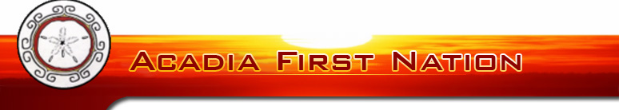

VIDEO CONSENT AND RELEASE FORM
I hereby give my consent to Wasoqopa’q First Nation, affiliates and agents, to use my image or recordings in any publications or other media activities, including the internet for the purpose of Learn Mi'kmaq.
☐ permission to film, photograph, record my face and or voice
☐ permission to use my name and
☐ permission to use photographs, recordings, video or audio in part or in whole, to be shared within the Learn Mi'kmaq group and or any learning areas that we may share too, such as a closed Facebook group, or emailing to other class mates.
The consent is given and does not require prior approval by me.
Name: _______________________________
Signature: ______________________________
Date: __________________________________
Witness: ________________________________
I am over the age of 18 (if not, please have parent/guardian compete the below information)
Name of Child: _________________________________
Parent/Guardian: _________________________________
Parent/Guardian ___________________________________
Signature: _____________________________________
Date: _________________________________________

